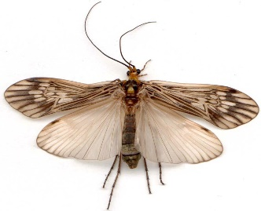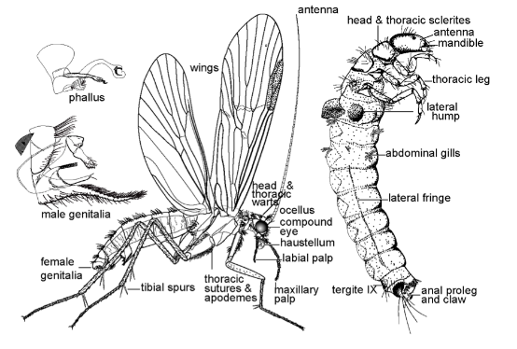

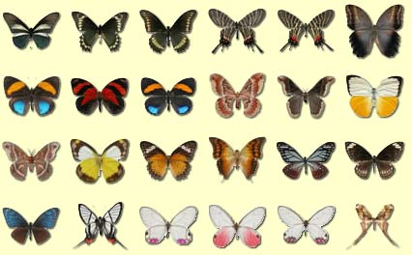

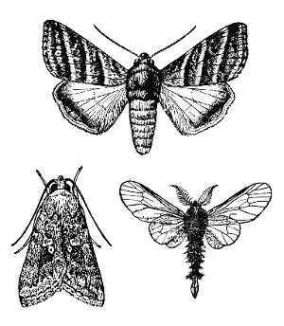

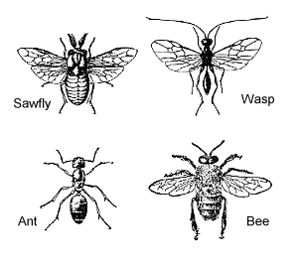



**Trichoptera – caddisflies**

Holometabola – complete development

Common worldwide

Larvae are aquatic and may be abundant in cool, fresh water habitats

Adults are less conspicuous and usually nocturnal (mean they only come out at night!!!)

Serve as food for fish

**Hymenoptera – bees/ants/wasps**

Holometabola – complete development

Regarded as ecological specialists

Evolved complex social systems with division of labor

Most are herbivorous and predatory or parasitic

For families go to 10.

**Lepidoptera – moths and butterflies**

Holometabola – complete development

Second largest order!

Adults distinctive for their large wings

Valued for their beauty and few are useful in commerce (silkworm!)

Destructive to agricultural crops and forest trees

For families go to 9